Bounty Hacker Solution Documentation
Written by: Yuval Quina
I started this challenge by scanning open ports on the target machine using Nmap:
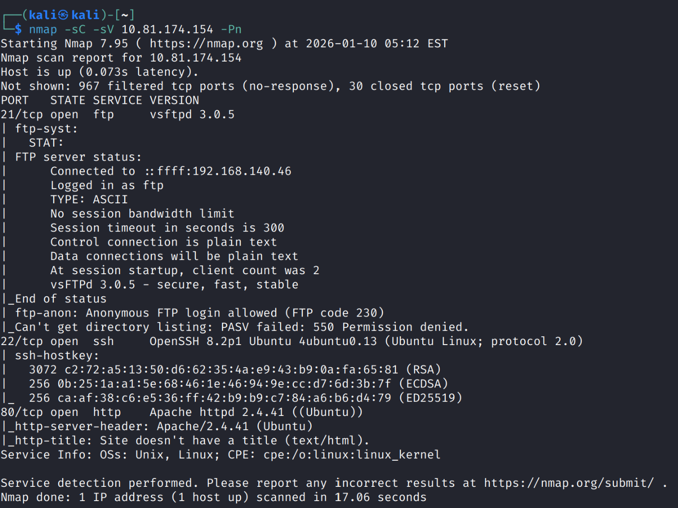
I found open port 80, so I accessed the target’s website, and this is how it looks like:
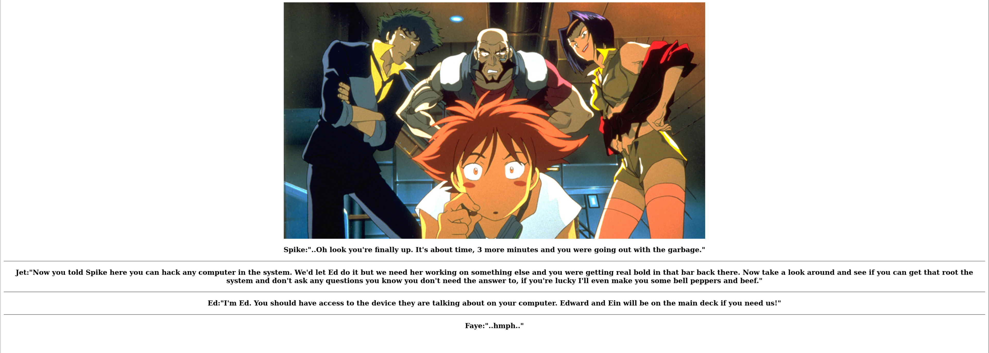
After reading the text, I continued by enumerating directories using gobuster:
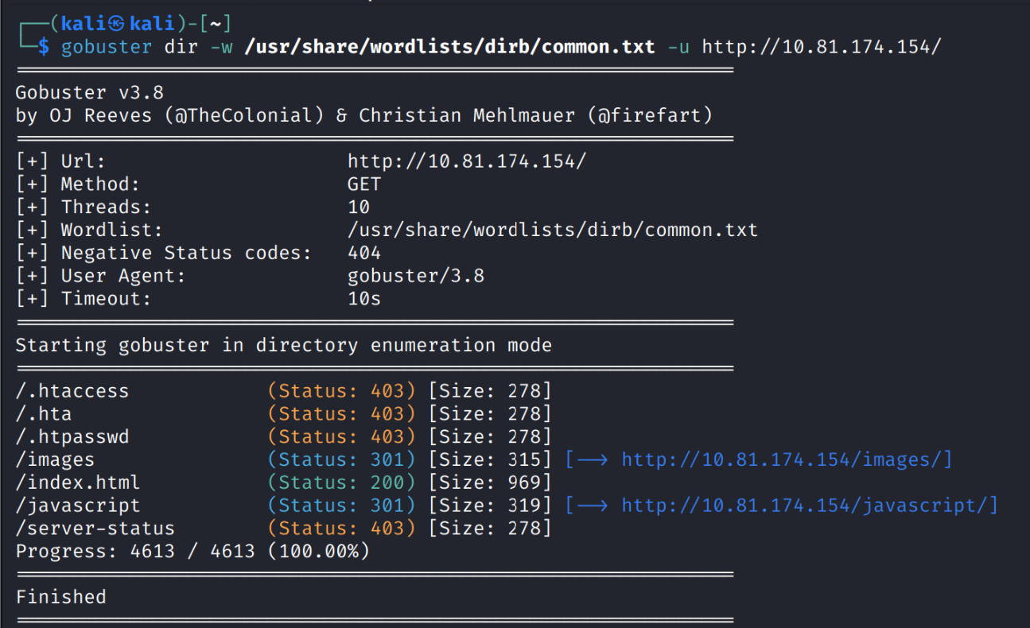
I entered the “/images” directory and found only this image (the same image that appears on the home page):
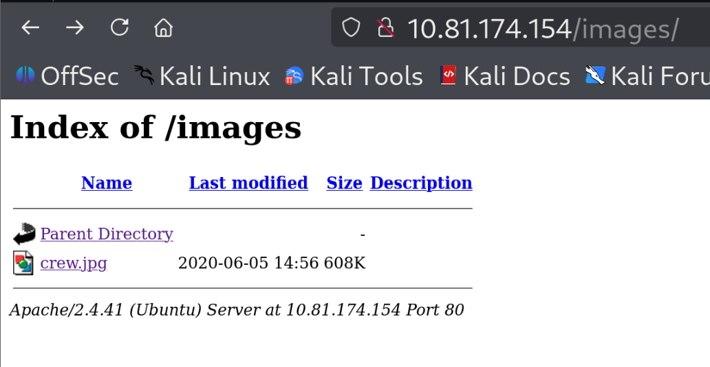
After I investigated some other directories, and found nothing, I moved to explore the ftp server:
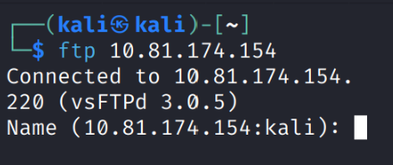
To my surprise, when I tried to enumerate directories, I faced this message from the server:
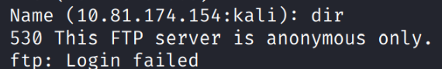
This message means that the ftp server accepts only anonymous user, so I entered the ftp server as the user anonymous with an empty password:
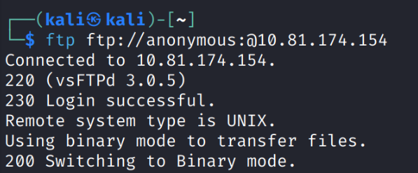
Immediately, after I logged in, I began enumerating directories and files again:
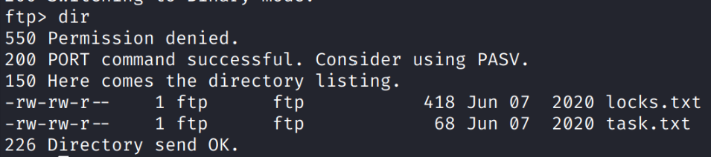
I found 2 files named “locks.txt” and “task.txt”, so I decided to download them to my machine:
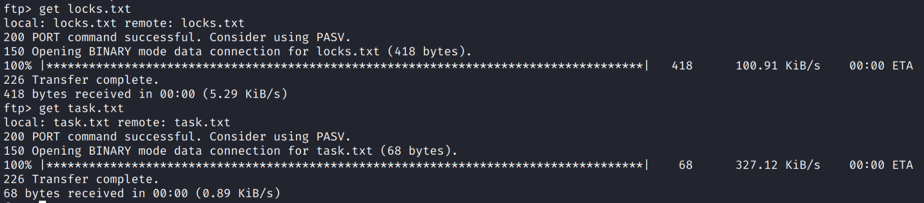
Here is their content:
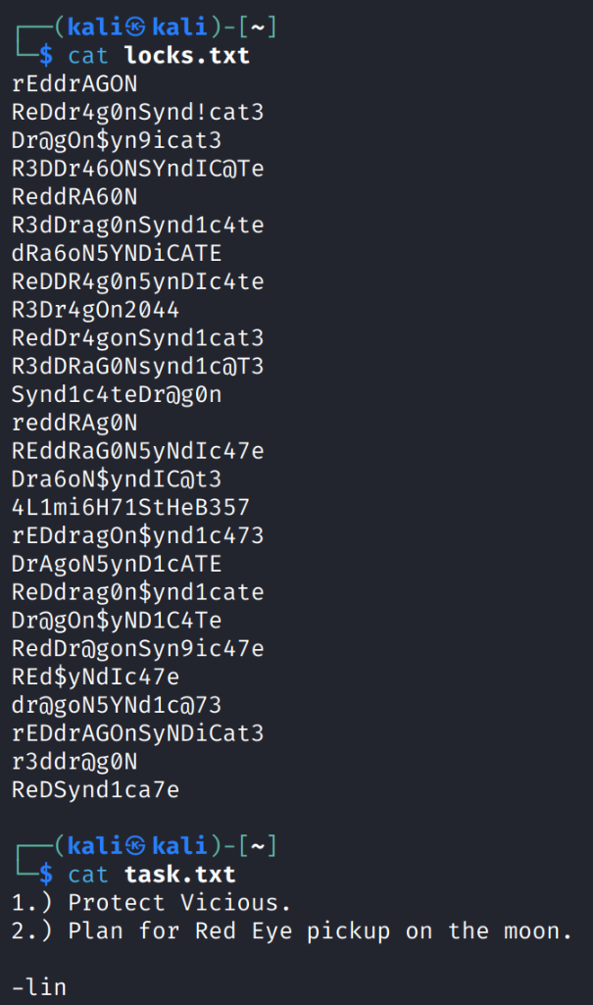
In the “task.txt” file I found the name of the writer of the task list, which is “lin”.
I looked a little bit more on the “locks.txt” file and thought that this is probably a list of possible passwords for the user “lin” in ssh. Therefore, I executed this bruteforce command with hydra to find lin’s password:
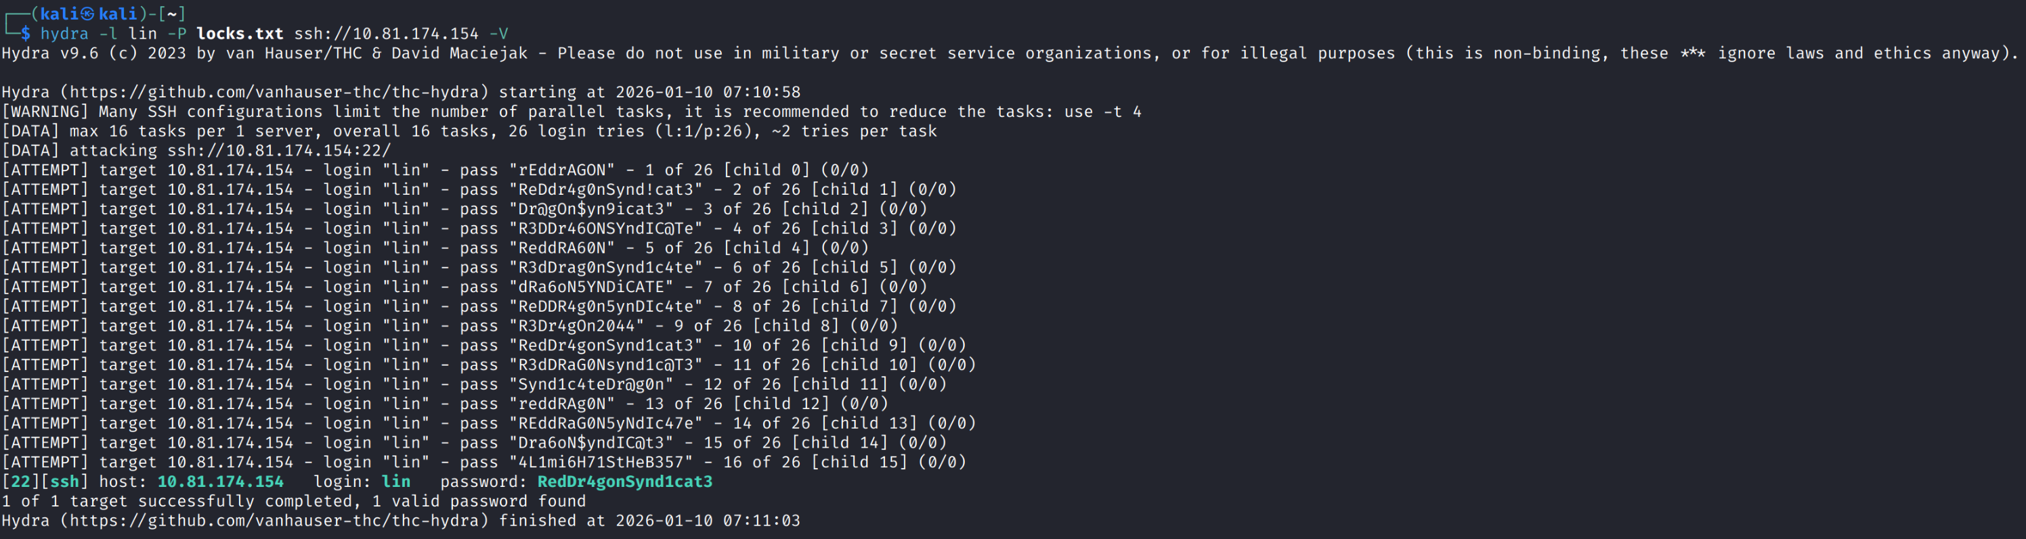
At the moment I found lin’s password, I accessed the target machine’s shell as the user “lin”:
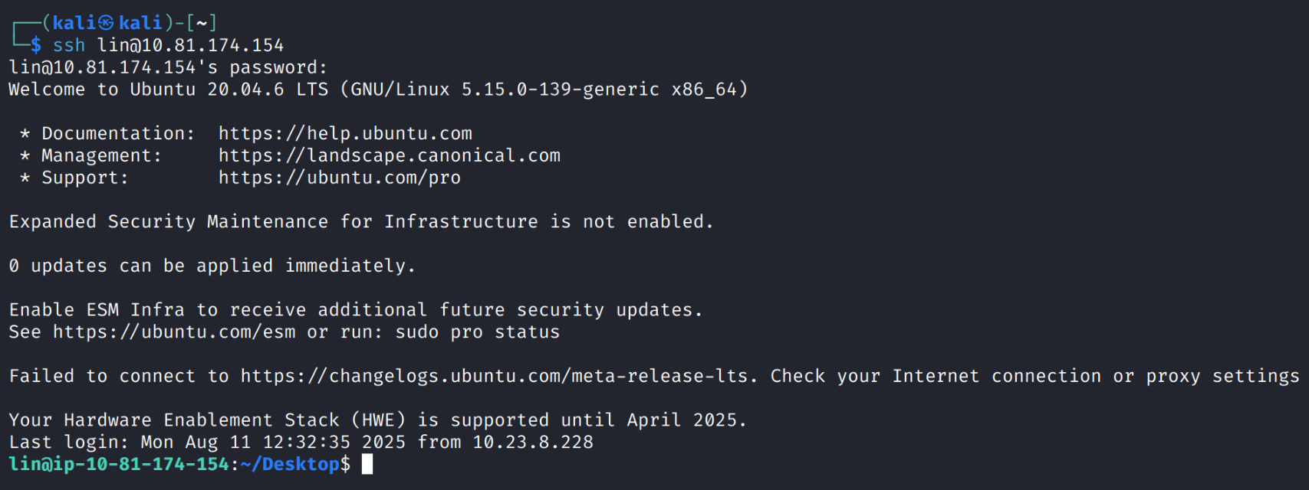
Now, I started searching for the “user.txt” file, which I found on the “/Desktop” directory:
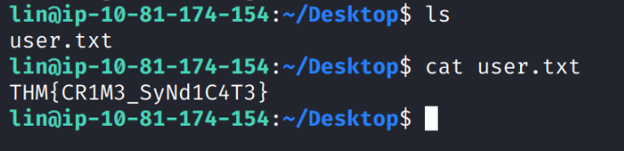
At this point, I moved to search the “root.txt” file. This is the reason I searches to escalate my privileges.
I started by understanding my root permissions as lin:
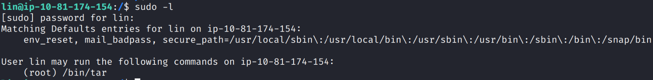
I found that I have root permissions while using the “/bin/tar/” binary, so I wanted to know more about it:
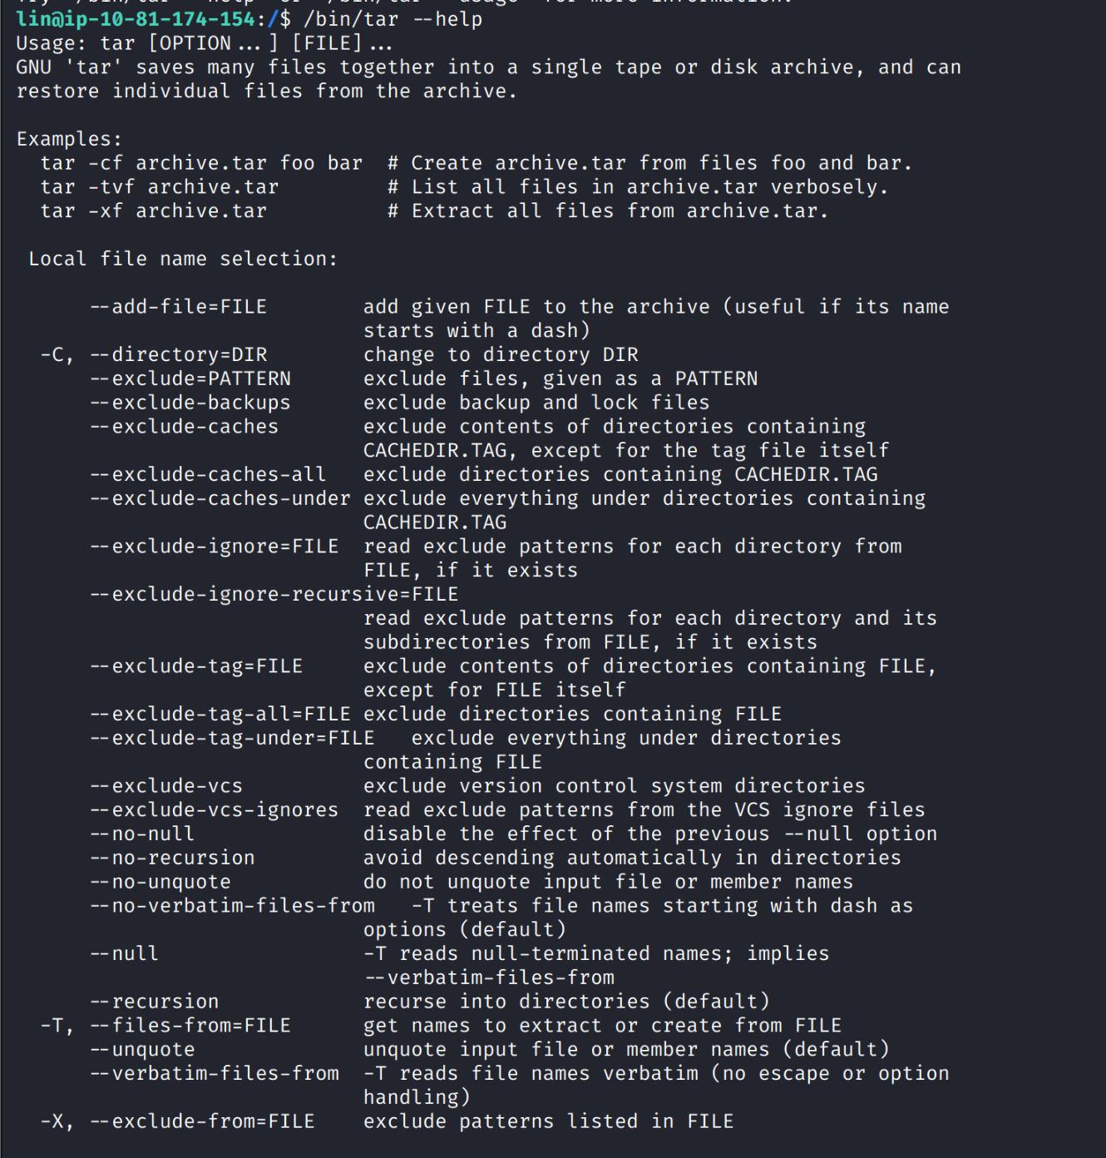
Here I understood that this binary is utility for tar archives.
At this point, I went to the website: “gtfobins.github.io” which is great source for finding information about Unix binaries that can be used to bypass local security restrictions in misconfigured systems.
I found on this website that tar command can help me escalate my privileges and get sudo permissions shell:
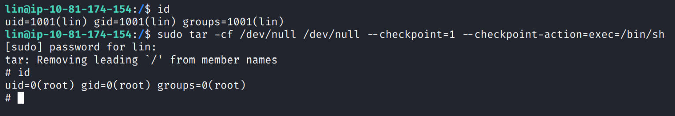
In short, this command creates an archive on /dev/null of /dev/null content (which has no content) and executing a specific command every 1 file it processes (because of the usage of the “checkpoint” feature). The point is that the command that it executes, with the checkpoint feature, is “/bin/sh” which creates a shell (with a sudo permission because of the sudo permission of the tar process) and by using this shell I can execute other commands as root.
To the end, I found the root.txt file in the “/root” folder:
